Please delete all the italic text before submission. It is here just for your reference.
Further: data set – DS, research question – RQ
The mark (x words) after each subchapter states the word count limit. This indicates the expected amount of information which you can exceed by 10% without losing the mark.

7COM1079-0901-2025 - Team Research and Development Project

Final report title: (the topic of your research.)

Group ID:

Dataset number:

Prepared by: [Name and ID of submitting student first],
[Name and ID of other group members]

Please make sure the document spelled correctly (including image labels, section headings, and table of contents). Please use correct punctuation.
Make sure your report is grammatically correct.

University of Hertfordshire
Hatfield, 2025

Table of Contents add page numbers from here

- Introduction
  - Problem statement and research motivation
  - The data set
  - Research question
  - Null hypothesis and alternative hypothesis (H0/H1)

- Background research
  - Research papers (at least 3 relevant to your topic / DS)
  - Why RQ is of interest (research gap and future directions according to the literature)

- Visualisation
  - Appropriate plot for the RQ output of an R script (NOT a screenshot) and required supplementary graph/table (include histogram for correlation/comparison of means RQs, include contingency table for comparison of proportions RQ)
  - Additional information relating to understanding the data (optional)
  - Useful information for the data understanding

- Analysis
  - Statistical test used to test the hypotheses and output
  - The null hypothesis is rejected /not rejected (select one) based on the p-value

- Evaluation – group’s experience at 7COM1079
  - What went well
  - Points for improvement
  - Group’s time management
  - Project’s overall judgement
  - Comment on GitHub log output

- Conclusions
  - Results explained.
  - Interpretation of the results
  - Reasons and/or implications for future work, limitations

- Reference list
Harvard (author, date) format.
- Appendices
- R code used for analysis and visualisation.
- GitHub log output.

The list below outlines the chapter/subchapter numbers, names, word count limits, and explanations of what to write in each section.

1. Introduction
  - Problem statement and research motivation (100 words)

The pattern and intensity of rainfall vary greatly from region to region in India. In order to properly carry out analysis of climate change so as to be able to make good decisions pertaining to agriculture, it is essential to understand these patterns. In most analytical studies focused on the entire nation, very few considered narrowing it down to comparing regions within specific historical periods. Several studies have shown that rains in the Indian subcontinent defy uniformity, being largely dependent on monsoon cycles (Guhathakurta & Rajeevan, 2008). This study takes a look at whether significantly different mean annual rainfall was experienced between Andaman & Nicobar and Coastal Karnataka between the years 1930 to 1939. Through this comparison, the differences that we may discover can provide useful information for present-day crop planning and water management.

  - The data set (75 words)

Our dataset gives information on the records of rainfall in India from 1901 to 2015 across the various subdivisions/regions. Each row contains data about a specific region and year, alongside records of the rainfall measured for all twelve months as well as seasons and the annual rainfall for that region and year. This dataset is essential for climate trend analysis, as it aids in making comparisons across regions and decades, helping identify variability, extremes, and long-term rainfall behaviour.

  - Research question (50 words).

Is there a difference in the mean annual rainfall between the Andaman & Nicobar Islands and Coastal Karnataka regions in India from 1930 to 1939?

  - Null hypothesis and alternative hypothesis (H0/H1) (100 words)

- Null hypothesis (H₀): There is no difference in the mean annual rainfall between the Andaman & Nicobar Islands and Coastal Karnataka regions in India from 1930 to 1939.
- Alternative hypothesis (H₁): There is a difference in the mean annual rainfall between the Andaman & Nicobar Islands and Coastal Karnataka regions in India from 1930 to 1939.

- Background research

  - Research papers (at least 3 relevant to your topic / DS) (200 words)

In India, rainfall trends are crucial to agriculture to help understand climate change and managing water resources, as they directly influence drinking water availability, river flow, soil moisture, groundwater, hydropower generation, agricultural productivity, and national economies (Kuttippurath et al., 2021). The availability of fresh water depends on monsoonal precipitation (June to September) and rain-fed rivers, termed as Monsoon Mode by Singh et al., (2016)

Coastal Karnataka, located at the western coast of India, receives an average rainfall of 3456 mm (Ashwin et al., 2021). The region experiences intense monsoon rains that support its lush landscapes and enable the cultivation of key crops like rice, coconut, and spices. However, these heavy rains also trigger hazards like landslides, flash floods, Infrastructure damage and soil erosion, underscoring the need for effective planning and management.
Andaman & Nicobar Island’s location in the Bay of Bengal means they are at the front line of the Indian monsoon making them vital for tracking the monsoon's progression. While rainfall is crucial for the island’s lush ecosystem, understanding the variability of climate in the region is essential in controlling challenges like soil erosion and potential climate shifts that affect water supply, impacting both nature and local life.

  - Why RQ is of interest (research gap and future directions according to the literature) (100 words)
It is no secret that managers of water resources, researchers, and policymakers are increasingly at risk from climate change (Ciampittiello et al., 2023). Changes in the amount and distribution of rainfall are one of the primary effects of climate change that require immediate attention and in-depth study since this information may be used for effective water resource management. Rainfall is essential to people's livelihood in a nation like India, where they mostly rely on their agricultural methods and a variety of forest resources. Rainfall contributes to water supplies and agricultural development, but too much of it can cause floods and disturb daily life.

- Visualisation
  - Appropriate graphs for the RQ output of an R script (NOT a screenshot) (50 words)
- Explain the choice of the plot.
- Include your main plot relevant to the RQ type.
- Include histogram or contingency table (think what is suitable) in addition to the main plot.
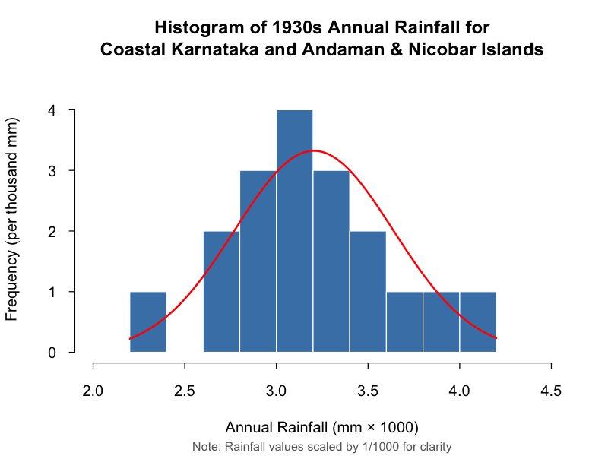
- Anything on the plot from R is not counted towards word count limit (e.g. legend, axes titles, name).
- Make sure that the plot is from output of an R script (NOT a screenshot).
- Make sure that the plot has a caption or title, X and Y-axis labels with units where appropriate, and legend.
- Make sure the title or caption and axis labels are informative and written in English.

  - Additional information relating to understanding the data (optional) (50 words)
The histogram shows the frequency distribution of annual rainfall (×1000 mm) for Coastal Karnataka and Andaman & Nicobar Islands between 1930 and 1939. Comparing the histogram with the overlay curve allows us to assess whether the rainfall follows a roughly normal pattern, and perform the appropriate statistical test.
Per plot: explain the purpose and insights.

  - Useful information for the data understanding (50 words)
- Summarise key observations from the plot.
The histogram shows rainfall clustering around 3.0 – 3.2 ×1000 mm, indicating consistent monsoonal patterns in the 1930s. The normal curve fits the data quite well, indicating consistent fluctuation from year to year. The absence of exceptionally low rainfall values suggests that there were no significant droughts during this time.

- Analysis
  - Statistical test used to test the hypotheses and output (75 words)
The histogram in Fig. 1 shows that the data distribution follows a normal bell curve, which indicates that for comparison of means, a t-test should be used. We used the independent t-test to test our data because we were comparing two separate, unrelated groups, which are two regions in India and their annual rainfall over a decade.

  - The null hypothesis is rejected /not rejected based on the p-value (100 words)
The t-test shows no statistically significant difference in mean annual rainfall between Coastal Karnataka and the Andaman & Nicobar Islands from 1930 to 1939 (t = 0.76269). Because the p-value is greater than 0.05 (p = 0.4573), we fail to reject the null hypothesis. The wide 95% confidence interval (-283.1992 to 599.4442), which includes zero, also indicates that the true difference in means could be small. Therefore, based on this sample, there is insufficient evidence to conclude that the two regions differ in their mean annual rainfall during this period.

- Evaluation – group’s experience at 7COM1079
  - What went well (75 words)
  - Points for improvement (75 words)
  - Group’s time management (50 words)
  - Project’s overall judgement (50 words)
  - Note any changes to group since original allocation if applicable. Add new or amended GitHub Ids for new members (75 words, write only if applies to your group arrangements)
  - Comment on the GitHub log output (50 words)
Please comment on the GitHub log output, and refer to it as being placed into Appendix B.
From your Git log, select three most significant commits during this project and include the following for each:
- Commit Message: [Insert Commit Message] Brief explanation of the broader impact of the change
- Commit Message: [Insert Commit Message] Brief explanation of the broader impact of the change
- Commit Message: [Insert Commit Message] Brief explanation of the broader impact of the change

- Conclusions
  - Results explained (75 words)
  - Interpretation of the results (75 words)
- Interpretation of what the results mean in terms of your RQ and the effect this may have on your population and the wider context of your topic.
  - Reasons and/or implications for future work, limitations of your study (50 words)

- Reference list (not included in the word count)
Ciampittiello, M., Marchetto, A. and Boggero, A. (2023). Water Resources Management under Climate Change: A Review. MDPI.

- Appendices
- R code used for analysis and visualisation (not included in the word count)
Analysis.R code with the appropriate statistics to test the hypotheses.
- No word count, but ensure the code is without redundant lines, well-commented and produces the correct output.
- Make sure it runs (look in Rscript.log for output from a statistical test)
- It should compute appropriate statistics to test the hypotheses
- GitHub log output.

